Amazon Kindle
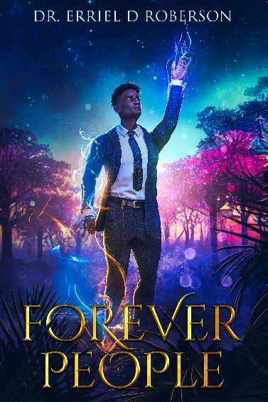
Synopsis
Brian Carrigan is awakened early by excruciating back pain, coupled with a strange recollection of an unusually lucid dream. He and wife Shannon, both physicists, are terrifyingly aghast to find stripes, flesh wounds, under his blood-streaked night shirt. The pair realize that Brian’s lucid dream was no dream, but a peregrination across time where he’d been whipped by a ravenous lynch mob! Yet here he was back in his comfortable bed again, after a seemingly random roundtrip jaunt across the fabric of universes.
Recounting what he has seen and experienced, Brian and Shannon race against time to arrange the pieces into a coherent, larger portrait like the most complex 50,000-piece jigsaw puzzle. The answers they discover along the way are frightening and alter the trajectory of both their lives, and even the world, as Brian is imbued with great power and tremendous responsibility. New revelations transport Brian back in time and across new dimensions again and again. He is confronted by new enemies and learns how he has come about receiving this gift and about who bestowed it upon him. When Shannon is dragged into the fray by sinister forces, the stakes become intensely high and crystal clear. Her husband is a descendant of the extraordinary Forever People and the world will never be the same! But there are those who don’t want the world to change…
Short Bio. For Dr. Roberson
- Forever People is Erriel’s debut novel
- Doctorate in Educational Psychology
- Science Fiction/Fantasy writer
- Science AND Musical Theater Geek
- Lived and traveled all over the world
- Loves Senegal, Barcelona and Alaska
- Avid reader and writer
- Married 34 years, living in Maryland

Author Extended Bio.
Dr. Erriel Roberson is an educator, social advocate, world traveler, and author of his debut science fiction/fantasy novel Forever People. Tananarive Due’s African Immortals series meets Ta-Nehisi Coate’s Water Dancer in Roberson’s Forever People. At once, a story of healing, love, redemption, and triumph, Forever People is honest, far-reaching, inspiring, and magical.
Erriel’s love of authentic narratives that free the imagination and reframe the world, as well as a hunger for social justice, led him to write Forever People and launch the Exordium series.
While he hasn’t time-traveled like his protagonist, after living throughout the US and England as a child Erriel Roberson has traveled as an adult from London to Morocco, Egypt, Barcelona, the Arctic Circle, fantastical worlds in his own mind, and many other places in between. A Doctor of Educational Psychology, he has applied his formal training to deeply layered character development and detailed world building.
Equally comfortable reading science fiction/fantasy or pumping iron in the gym, Erriel is a lifelong science nerd and former collegiate athlete. He brings a unique perspective and vibrant mental and physical energy to his writing and speaking. Erriel lives and works from his home in Maryland.
Sample Interview Questions
- What went into your decision to write a novel?
- As a reader what do you look for in a novel?
- What inspires you?
- Do you see a role for your work in the battle for social justice?
- What does science fiction/fantasy have to do with social justice?
- What is your writing process and what do you recommend for those who feel like they have a novel somewhere inside of them?
- What was your intention when writing your novel? Was it just to write a story, to get a message out, or what was it?
- Have you started working on the next books in this series?

Excerpt:
“He was such an active and brilliant mind. It would be his undoing. Brian’s reality was such that the ordinary and vicious tribulations of that time period he had disappeared into would render him hysterical. Not in any sense of weakness, but it would be un-survivable. Wouldn’t it?
Shannon’s own personal travails and scattered emotional explorations began to wind down in her gut like a spinning top coming to the end of its rapid revolutions. The pit remained in her stomach but everything else began to succumb to exhaustion. Her lids grew heavy even as softly in the background of her thoughts she reflected on the fact that her husband remained separated from her by time and dimension. She had read and re-read Brian’s and her own notes several times over the span of a couple of hours. Surprisingly, in her reflection she had also had time to tinker with random yet very specific lab procedures and experiments hoping to think her way through what Brian told her she had to feel. But what does it mean for a scientist to feel their way to extra-dimensional travel? To feel their way across the Brane? To feel her way to her husband?”

Contact Dr. Roberson
- wherewewin1@gmail.com
- errielroberson@gmail.com
- www.errielroberson.com
- 6000 Merriwether Drive
Unit 4102
Columbia. MD 21044
- 443-253-9189

Photos:
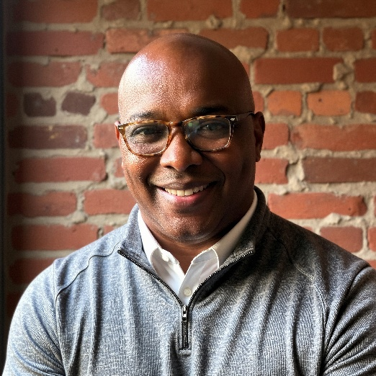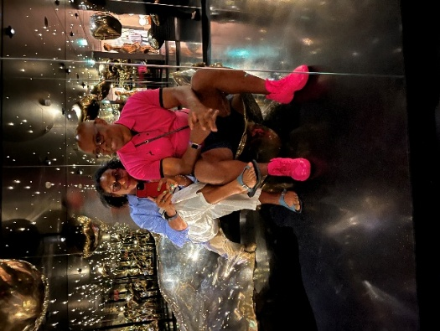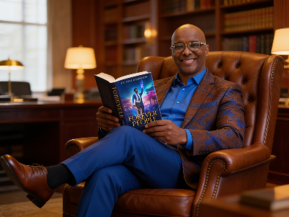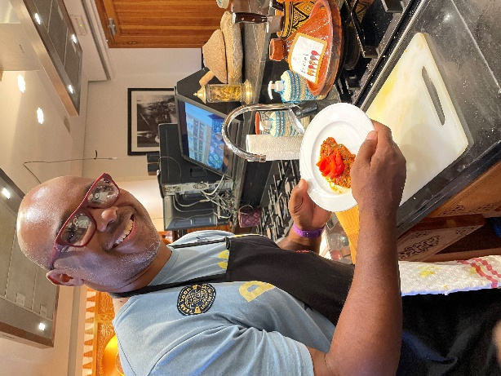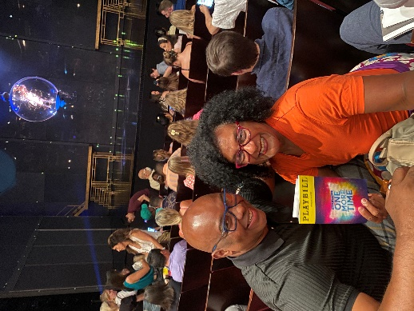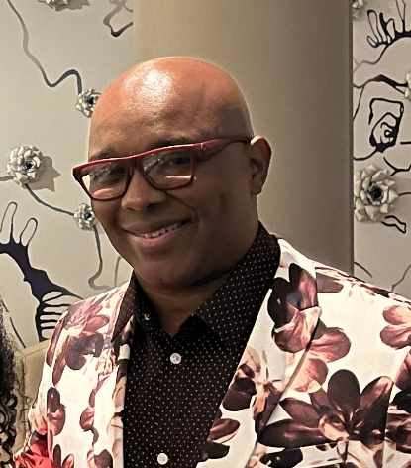

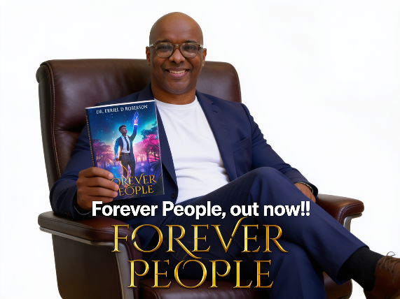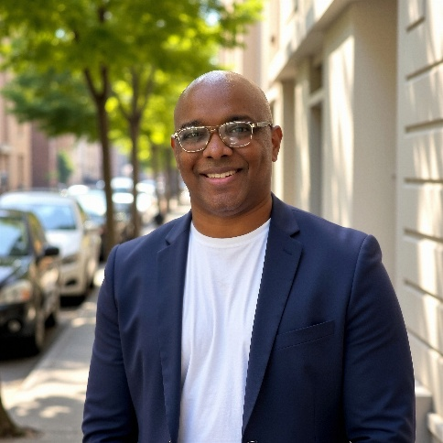

Short-list of some Favorites (not enough room for everything.)
